**DETAILED SOLUTION DESIGN AND ARCHITECTURE**

**Architecture of Border Patrolling Multifunctional Robot**

It is a 6-wheel drive robot vehicle that can overcome the obstacle in its path. It is designed to maneuver in all terrains without difficulty. This robot is controlled remotely by remote station through a web interface. This interface is user friendly and user can control the bot and can receive the data from the sensors directly to the screen. The communication end points in this project are sensors to raspberry, Raspberry to cloud, cloud to user via web interface. single, discrete communication message exchanged between a robot and infrastructure.

User communicates with the robot through cloud. Cloud sends the control data to the raspberry and raspberry sends the sender information through cloud. Raspberry controls the other components of the robot and communicates within the processor.

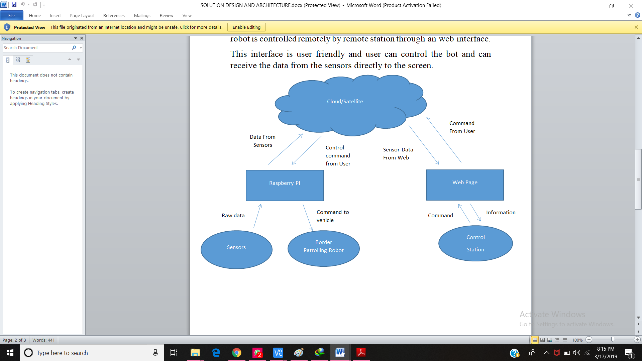

**Design and development of Robot**

The multifunctional robot is designed completely to be operable with cloud web server. The robot can be controlled with remote station. This is platform independent project can be implemented anywhere in any system. The user friendly interface is designed to avoid complexity in controlling the bot. Raspberry pi is connected to laptop wirelessly. Raspberry pi is controller of the robot. It controls the sensors and DC motors and logical activity of its component.

Raspberry then sends the data to the cloud and user access the data from cloud through web server. Web server is developed using **flask framework** of python and backend code is written in python 3.

There is a web app on laptop which displays video stream and reports control data that is live streaming of video and control arrows to control its movement according to our need. Through web server we can send control data to raspberry pi and receive data from it. It also sends and receive data through various sensors in our model there are various sensors used to make our bot multifunctional. There is a web cam to continuously stream the situation at the border. Through GPS sensor we get to know latitude and longitude of our bot where it is moving at what position. Temperature sensors are used to get climatic situations, humidity etc. Motor drivers are used to drive bot. Raspberry-pi uses 5v of battery and also motor uses 12v of power to drive wheels.

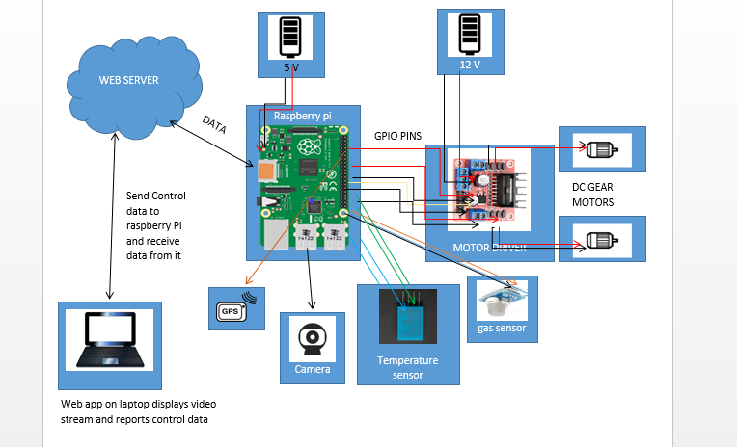

Initiates live streaming

Click button for movement

Any Sensors Active

Send Alert to the user interface

**DATA FLOW DIAGRAM FOR MULTIFUNCTIONAL BORDERPATROLLING ROBOT.**

Firstly, on the web interface live streaming starts and there is an interface on which arrows are there which are needed to be clicked for the movement of robot forward backward right left. Then at the same time it displays the information from various sensors like temperature, detecting how far any person or any obstacle is from the bot. If button clicked for the movement of bot it moves in that direction otherwise it stops.